**Demo of lfgen.exe and lfcopy.exe**  
Generate a load file consisting of 10 parent documents, each with 2 embeddings:  
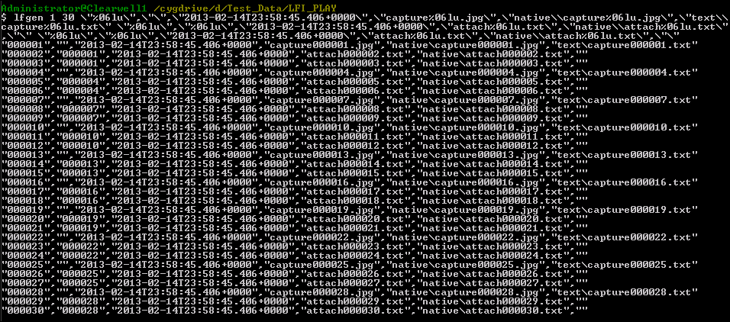  
  
Repeat and save to a file this time:  
  
  
Create the corresponding test files, from a an initial set of files:  
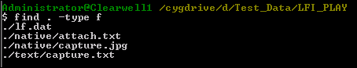  
  
Create 30x attach.txt:  
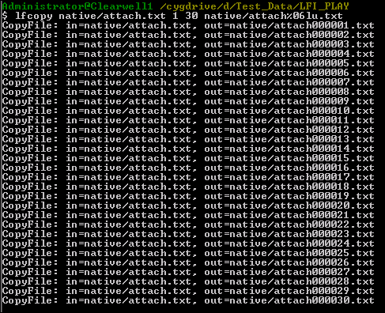  
  
Create 30x capture.jpg:  
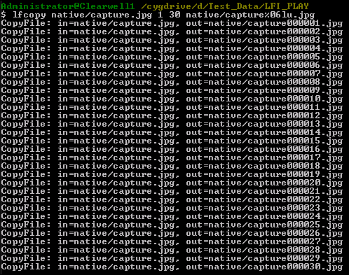  
  
Create 30x capture.txt:  
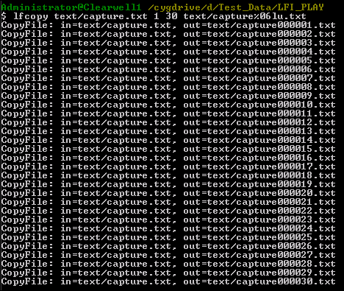  
  
  
Import the data into CW, using the following settings:  
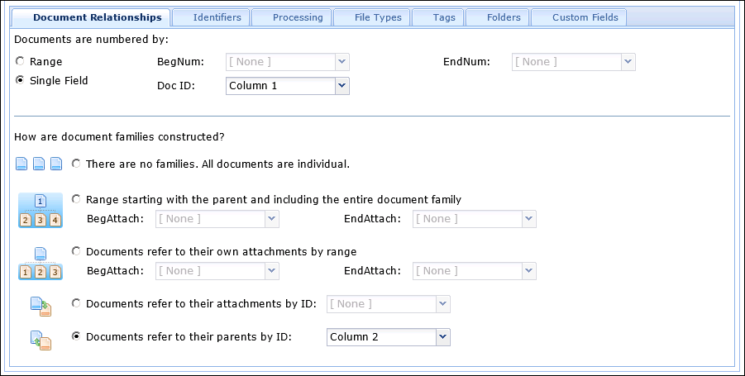  
  
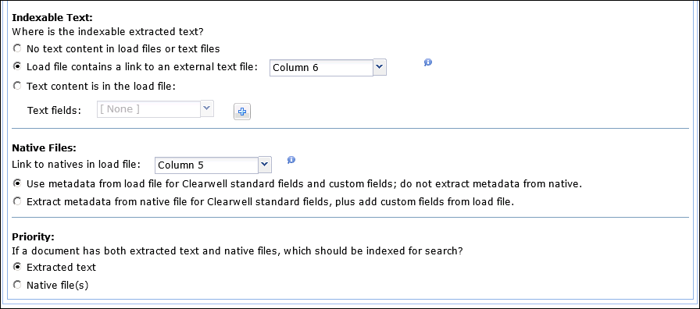  
  
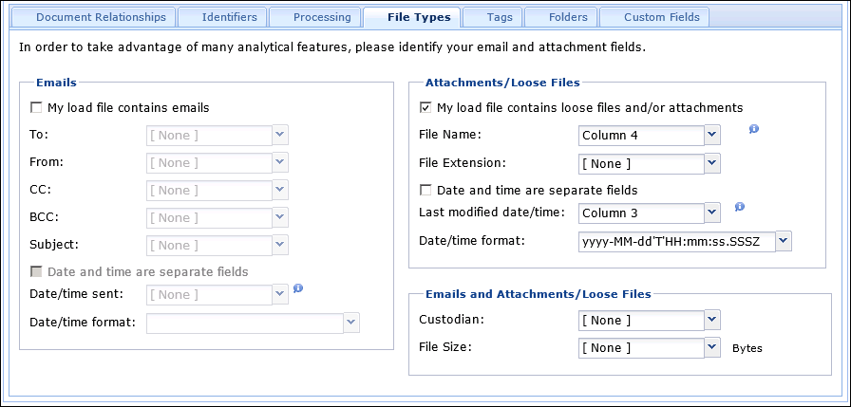  
  
After processing:  
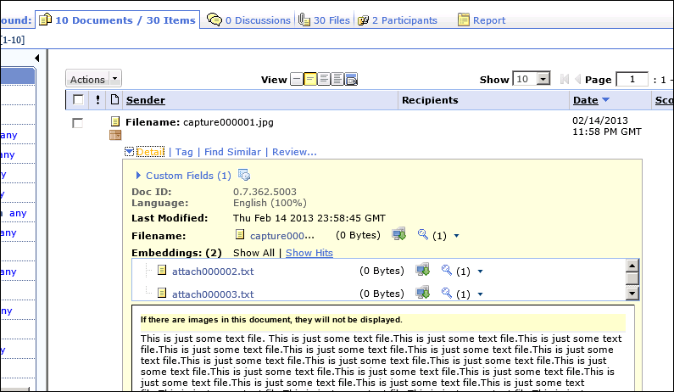  
  
**END**